|  |
| --- |
| **Philly CRM 311**  **Technical Design – Complaint against Fire or EMS**  **V1.0** |
|  |

# REVISION HISTORY

|  |  |  |  |
| --- | --- | --- | --- |
| **Revision Number** | **Revision Date** | **Summary of Changes** | **Author** |
| Draft | 04/30/2014 | Created Draft based on 1.7 of SR | Murugaboopathi |
| 1.0 | 05/01/2014 | Modified based on the Design Review | Murugaboopathi |

# 1 - TABLE OF CONTENTS

REVISION HISTORY 2

1 - TABLE OF CONTENTS 3

2 – SERVICE REQUEST INFORMATION 4

2.1 ENTITY RELATIONSHIP DIAGRAM 4

2.2.1 CASE STANDARD FIELDS 5

2.2.2 CUSTOM FIELDS 6

2.2.3 Dependent Picklist 8

2.2.4 Force.com Objects 8

2.3 HIGH LEVEL SYSTEM PROCESS FLOW 10

3 - NEW FUNCTIONALITY 11

3.1 CONFIGURATION DETAILS 11

3.2 DATA SHARING MODEL 13

3.3 CUSTOM DEVELOPMENT DETAILS 13

4 – STANDARD CASE FIELDS 18

4.1 DEPARTMENT DETAILS SECTION 18

4.2 CASE DETAIL/INFORMATION SECTION 19

4.3 SERVICE REQUEST LOCATION SECTION 21

4.4 CASE LOCATION SECTION 21

4.5 DESCRIPTION INFORMATION SECTION 22

4.6 RESOLUTION INFORMATION SECTION 22

4.6 WEB INFORMATION SECTION 23

4.7 SYSTEM INFORMATION SECTION 24

# 2 – SERVICE REQUEST INFORMATION

|  |  |
| --- | --- |
| **Case Record Type :** | Complaints against Fire or EMS |
| **Service Request ID** | SR-FD01: Complaints against Fire or EMS |
| **Service Request Type** | Complaints against Fire or EMS |
| **Department** | Fire Department |

|  |
| --- |
| 2.1 ENTITY RELATIONSHIP DIAGRAM |



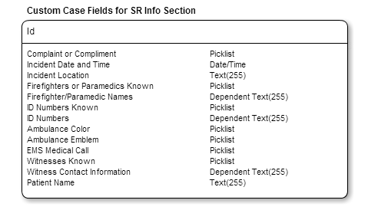

|  |
| --- |
| 2.2.1 CASE STANDARD FIELDS |

|  |  |  |  |  |  |  |  |  |  |
| --- | --- | --- | --- | --- | --- | --- | --- | --- | --- |
| **Field Label** | **Field Name** | **Data Type** | **Required** | **Unique** | **Default Value** | **External ID** | **Rule #** | **History** | **Help Text** |
| Status | Status | Picklist  **Values:** New, In-Progress, Escalated, On Hold, and Closed | Yes | No | New | No | None | Yes |  |
| Case Origin | Origin | Picklist  **Values:** Phone, Email, Web | Yes | No | Phone | No | None | Yes |  |
| Priority | Priority | Picklist  **Values:** High, Medium, Low | Yes | No | Medium | No | None | Yes |  |

|  |
| --- |
| 2.2.2 CUSTOM FIELDS |

|  |  |  |  |  |  |  |  |  |  |
| --- | --- | --- | --- | --- | --- | --- | --- | --- | --- |
| **Field Label** | **Field Name** | **Data Type** | **Required** | **Unique** | **Default Value** | **External ID** | **Rule #** | **History** | **Help Text** |
| Complaint or Compliment | Complaint_or_Compliment__c | Picklist  Values: Complaint, Compliment | Yes |  |  |  | None | No | Is this report a complaint or a compliment? |
| Incident Date and Time | Incident_Date_and_Time__c | Date/Time | Yes |  |  |  | None | No | When did the incident happen (date and time)? |
| Incident Location | Incident_Location__c | Text(255) | Yes |  |  |  | None | No | In addition to the service address entered, what other details describe the location of the incident? |
| Firefighters or Paramedics Known | Firefighters_or_Paramedics_Known__c | Picklist  Values: Yes, No | Yes |  |  |  | None | No | Are the names of the firefighters or paramedics known? |
| Firefighter/Paramedic Names | Firefighter_Paramedic_Names__c | Dependent Text(255)  Firefighter/Paramedic Names is enabled and required when Firefighters or Paramedics Known = ‘Yes’. | No |  |  |  | Validation Rule #1 | No | What are the names of the firefighters or paramedics (if available)? |
| ID Numbers Known | ID_Numbers_Known__c | Picklist  Values: Yes, No | Yes |  |  |  | None | No | Is the ID number of the fire or medic vehicle involved known? |
| ID Numbers | ID_Numbers__c | Dependent Text(255)  ID Number is enabled and required when ID Number Known = ‘Yes’. | No |  |  |  | Validation Rule #2 | No | What are the ID numbers of the fire or medic vehicles involved (if available)? |
| Ambulance Color | Ambulance_Color__c | Picklist  Values: Red and White, Other | Yes |  |  |  | None | No | Is the ambulance red and white? |
| Ambulance Emblem | Ambulance_Emblem__c | Picklist  Values: Philadelphia Fire Dept, Other | Yes |  |  |  | Workflow Rule #1, Workflow Rule #2 | No | Does the ambulance say Philadelphia Fire Department? |
| EMS Medical Call | EMS_Medical_Call__c | Picklist  Values: Yes, No  Default: | Yes |  |  |  | Workflow Rule #3 | No | Was the incident a medical call to the Regional EMS? |
| Witnesses Known | Witnesses_Known__c | Picklist  Values: Yes, No | Yes |  |  |  | None | No | What are the names of the witnesses (if available)? |
| Witness Contact Information | Witness_Contact_Information__c | Dependent Text(255)  Witness Contact Information is enabled and required when Witnesses Known = ‘Yes’. | No |  |  |  | Validation Rule #3 | No | What is the contact information for the witnesses? |
| Patient Name | Patient_Name__c | Text(255) | No |  |  |  | None | No | What is the name of the patient (if known)? |

|  |
| --- |
| 2.2.3 Dependent Picklist |

**Dependent Picklist Rule #1:**

Controlling field Name: Firefighters or Paramedics Known

Dependent Field Name: Firefighter/Paramedic Names

Values = Yes, No

Firefighter/Paramedic Names is enabled and required when Firefighters or Paramedics Known = ‘Yes’.

**Dependent Picklist Rule #2:**

Controlling field Name: ID Numbers Known

Dependent Field Name: ID Numbers

Values = Yes, No

ID Number is enabled and required when ID Number Known = ‘Yes’.

**Dependent Picklist Rule #2:**

Controlling field Name: Witnesses Known

Dependent Field Name: Witness Contact Information

Values = Yes, No

Witness Contact Information is enabled and required when Witnesses Known = ‘Yes’.

|  |
| --- |
| 2.2.4 Force.com Objects |

|  |  |  |
| --- | --- | --- |
| **Custom/Standard** | **Existing Objects** | **New Objects** |
| Standard | Case |  |
| Standard | Account |  |
| Standard | Contact |  |
| Custom | PKB Article Deflection |  |

|  |
| --- |
| 2.3 HIGH LEVEL SYSTEM PROCESS FLOW |



# 3 - NEW FUNCTIONALITY

|  |
| --- |
| 3.1 CONFIGURATION DETAILS |

**Case Record Type:** *Complaints against Fire or EMS*

Label: Complaints against Fire or EMS

Support Process: Complaints against Fire or EMS Support Process

Support Process Selected Values:

* New (Default)
* In-Progress
* Escalated
* On-Hold
* Closed (Closed)
* Open
* Completed
* Home Inspection Only

Record Type Name: Complaints against Fire or EMS

**Buttons:**

* Case Edit
  + Save
  + Save & Close
  + Cancel
* Case Detail
  + Edit
  + Delete
  + Close Case
  + Clone

**Tab Setup:**

**App Setup:**  Call Center Console

**User Profile Setup:**

* 311 Agents
* 311 Supervisors
* Case Workers
* System Administrators

**Permission Set Setup:** Please refer Profile & Permission Setup and Profile technical design.

**Role Hierarchy Considerations:** TBD

**Workflows:**

|  |  |  |  |  |  |
| --- | --- | --- | --- | --- | --- |
| **Rule #** | **Rule Name** | **Workflow Action** | **Rule Criteria** | **Object** | **Evaluation Criteria** |
| 1 | Workflow Rule for *Ambulance Emblem (Regional EMS)* | Set the queue to **‘**Complaint for Regional EMS’. | *Ambulance Color* = ‘Other’ AND *Ambulance Emblem* = ‘Other’ | Case | Evaluate the rule when the value in a field(s) is populated/updated to a specific value. |
| 2 | Workflow Rule for *Ambulance Emblem (Fire Department)* | Set the queue to **‘**Complaint for Regional EMS’. | *Ambulance Color* = ‘Red and White’ OR *Ambulance Emblem* = ‘Philadelphia Fire Dept’ | Case | Evaluate the rule when the value in a field(s) is populated/updated to a specific value. |
| 3 | Workflow Rule for *EMS Medical Call* | Set the queue to **‘**Complaint for Regional EMS’. | *EMS Medical Call* = ‘Yes’ | Case | Evaluate the rule when the value in a field(s) is populated/updated to a specific value. |

**Approval Processes:**  None

**Reports & Dashboards:** None

**Validation Rules**

|  |  |  |  |  |
| --- | --- | --- | --- | --- |
| **Rule No** | **Rule Name** | **Conditions** | **Message** | **Comments** |
| 1 | Validation Rule for *Firefighter/Paramedic Names* | The *Firefighter/Paramedic Names* field must be populated (not NULL) if *Firefighters or Paramedics Known* = ‘Yes’. |  |  |
| 2 | Validation Rule for *ID Numbers* | The *ID Numbers* field must be populated (not NULL) if *ID Number Known* = ‘Yes’. |  |  |
| 3 | Validation Rule for *Witness Contact Information* | The *Witness Contact Information* field must be populated (not NULL) if *Witnesses Known* = ‘Yes’. |  |  |

**Queue(s) :** *Complaint for Fire Department*

*Complaint for Regional EMS*

**Queue Members for** Complaint for Fire Department : TBD

**Queue Members for** Complaint for Regional EMS : Richard.Bossert@phila.gov

**Email Notifications:** if the Agent is selected “Send Notification Email to Contact” checkbox then send Email to Contact using “Case Creation” template.

**Public Groups:** None

**Sharing Rules:**

|  |  |  |  |
| --- | --- | --- | --- |
| **Rule Name** | **Criteria** | **Shared With** | **Access Level** |
|  |  |  |  |
|  |  |  |  |
|  |  |  |  |

**Custom Report Types:** None Defined

**Chatter Enabled Objects:** NONE

**Documents And Attachments** :

**Flow/Agent Instructions(Left side of the Layout)**:

|  |
| --- |
| * Purpose: To report a complaint or a compliment for a EMS Provider or Fire Department. * Do not transfer the customer's call. These complaints are handled via a case and responded to by the appropriate Fire/EMS unit. To escalate complaints that have not been responded to, the 311 Supervisor may contact the Office of the Fire Commissioner at (215) 686-1300. * Contacts field: Enter the customer’s name, address, and phone number for follow up.   + Advise the customer that this information is requested in the event the department needs to obtain more information to follow up on this request.   + If the customer does not wish to leave their contact information, advise the customer that if the inspector cannot locate the issues identified, the case will have to be closed out.  Ask the customer, “Are you sure you want to submit this request anonymously?” * Service Address field: Enter the address of the location where the incident occurred?   + Verify that you entered the address correctly by repeating the address back to the customer. * Description field: Describe the nature of the complaint against the Paramedic, EMS, Firefighter, and/or the Fire Department. * Advise the customer:   Once a case is entered into the system the Fire Department will follow up with the customer within 1 business day by phone and a formal letter will be sent within 2 business days. Depending on the nature of the complaint, investigations may take several business days. The customer will be given an approximate length of time to complete the investigation by the Fire Department on the follow up call. |

|  |
| --- |
| 3.2 DATA SHARING MODEL |

|  |  |  |  |
| --- | --- | --- | --- |
|  | ***User Types*** | ***Permission Sets*** | ***Public Groups*** |
| *LEVEL 1* |  |  |  |
| *LEVEL 2* |  |  |  |
| *LEVEL 3* |  |  |  |

|  |
| --- |
| 3.3 CUSTOM DEVELOPMENT DETAILS |

**Visualforce Pages**

* For Case Location Section in Case Detail: Create a VF Page which will use SR Location to depict Street,City,State in a Map.

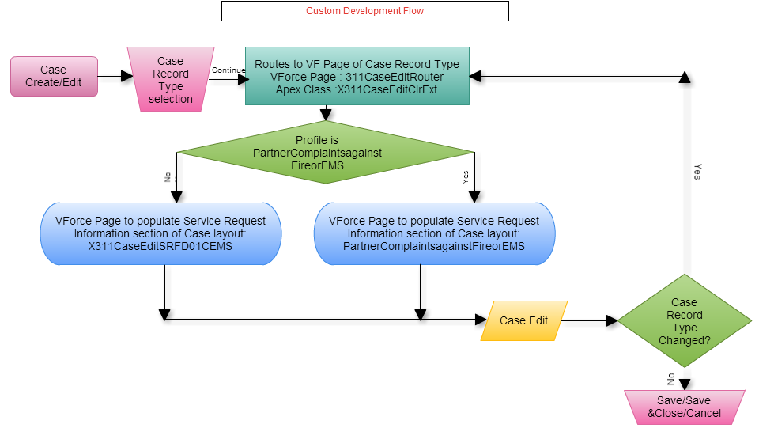

**Custom Flow :** For standard button New/Edit button is replaced with a custom Visualforce Page **X311CaseEditRouter**. All the Visual force pages and related extensions are defined as follows.

**Visual Force Page : X311CaseEditRouter**

**Purpose:**  To route to SR specific Visual force page.

<apex:page standardcontroller="Case" extensions="X311CaseEditClrExt" action="{!redir}">

</apex:page>

**Apex Class : X311CaseEditClrExt**

public PageReference redir() {

* + - 1. Get current page parameters.
      2. Get the relevant Page depending on the Profile and Record Type(X311CaseEditNS01Graffiti or PartnerGraffitiRemoval)..
      3. Redirect to the page with parameters.

}

**Visual Force Page : X311CaseEditSRFD01CEMS**

<apex:page standardcontroller="Case">

<apex:composition template="X311CaseEdit">

<apex:define name="typeSpecific">

<apex:pageblocksection title="Service Request Information" showheader="true" collapsible="true" columns="2">

**SR Complaints against Fire or EMS SPECEFIC FIELDS**

</apex:pageblocksection>

</apex:define>

</apex:composition>

</apex:page>

**Visual Force Page : X311CaseEdit**

<apex:page standardcontroller="Case" extensions="X311CaseEditClrExt">

<apex:pageblock mode="edit">

<apex:pageblocksection title="Department Details">

</apex:pageblocksection>

<apex:pageblocksection title="Case Information">

</apex:pageblocksection>

<apex:pageblocksection title="Service Request Location">

</apex:pageblocksection>

<apex:inputTextArea id="caseInternalComments" >

</apex:pageblocksection>

<apex:pageblocksection title="Description Information">

</apex:pageblocksection>

<apex:pageblock>

</apex:page>

**Visual Force Page : PartnerComplaintsagainstFireorEMS**

<apex:page standardcontroller="Case" extensions="X311CaseEditClrExt">

<apex:pageblock mode="edit">

<apex:pageblocksection title="Department Details">

</apex:pageblocksection>

<apex:pageblocksection title="Case Information">

</apex:pageblocksection>

<apex:pageblocksection title="Service Request Location">

</apex:pageblocksection>

<apex:inputTextArea id="caseInternalComments" >

</apex:pageblocksection>

<apex:pageblocksection title="Service Request Information" showheader="true" collapsible="true" columns="2">

**SR Complaints against Fire or EMS SPECEFIC FIELDS**

</apex:pageblocksection>

<apex:pageblocksection title="Description Information">

</apex:pageblocksection>

<apex:pageblock>

</apex:page>

**Triggers**

|  |  |  |  |  |  |
| --- | --- | --- | --- | --- | --- |
| **Trigger Name** | **Parent**  **Object** | **Child**  **Object** | **Trigger**  **Event** | **Operation**  **Type** | **Description** |
| CalculateBusinessHoursAges | Case |  | Before update | Insert | Calculates the total business hours between when a case was opened and when it was closed and then populates “Case Age in Business Hours” field, which is displayed in the “Age to Close in Business Hours” field shown within the “Resolution Information” section of the case |
| Account_Name_Update | Contact |  | Before update | Insert | When a new Contact is created during the case creation process, the system does not allow for an Account to be associated to the Contact, yet Account is a required field for a Contact. Whenever a new Contact is created without an Account, this trigger will associate the Account record with Name = “City of Philadelphia” to the Contact record |

**Apex Code:**

**Force.com sites:**

**Javascript:**

**Web Service/API Code:**

**Customer Portals:**

**Communities:** Community Partner Self-Service Portal

**Site.com:**

**Third Party Applications:**  Survey Force, Sales for Social Media & Call Center Console

**Other**

**Layout:** Complaints against Fire or EMS

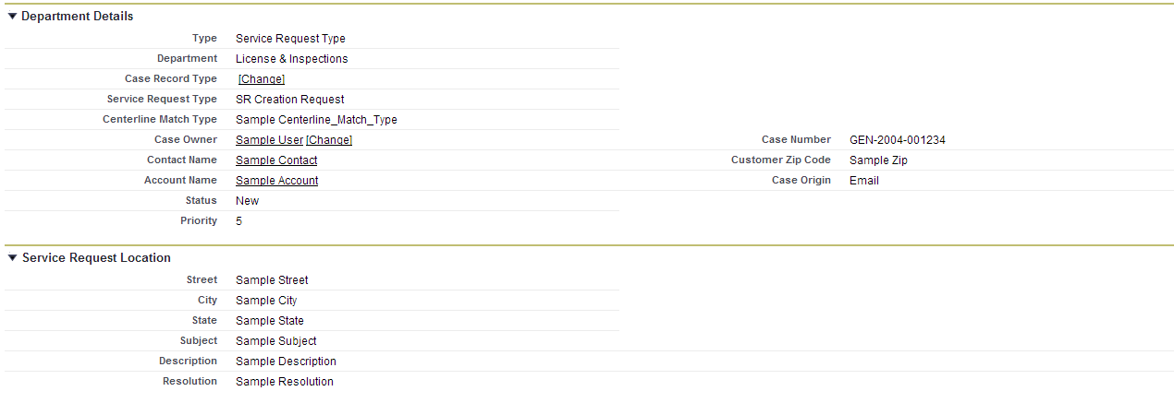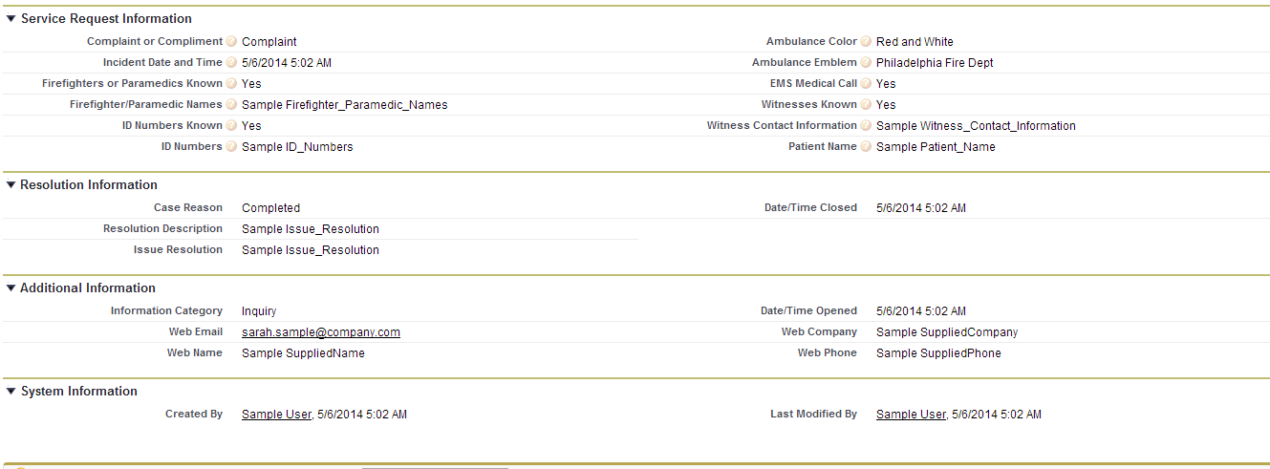

Related Lists :

* Solutions
* Open Activities
* Activity History
* Case Comments
* Case History
* Attachments

# 4 – STANDARD CASE FIELDS

|  |
| --- |
| 4.1 DEPARTMENT DETAILS SECTION |

|  |  |  |  |  |  |  |  |  |  |  |  |
| --- | --- | --- | --- | --- | --- | --- | --- | --- | --- | --- | --- |
| **Field Label** | **Field Name** | **Field Type** | **Custom** | **Default** | **Required** | **Unique** | **Read Only** | **External ID** | **Validation** | **History** | **Comments** |
| Type | Type | Picklist  **Values:** Service Request Type, Information Request Type, Directory Services | N | Service Request Type | Y |  | N | N | None | Y | Field is initially auto-populated based on the Case Record Type being created. If this value is manually changed, it will result in a new Field Layout based on the new Case Record Type. |
| Department | Department__c | Picklist  **Values:** Neighborhood Services | Y | Service Request Type | Y |  | N |  | None | N | Department will be automatically set based on Service Request Type. For an Information Request, this field will be automatically populated by the article. For Directory Services the field will default to 311 Services. |
| Service Request Type | Service_Request_Type__c | Picklist  **Values:** Graffiti Removal | Y | Graffiti Removal | Y |  | N |  | None | Y | This field is initially auto-populated based on the Case Record Type chosen when creating the case. If this value is changed, it could result in a new Field Layout based on the new Case Record Type chosen.  If any value in the Other Case Information systems indicates that this should not be forwarded to another department as a Service Request, a value of “Request Not Required” will be assigned to this field, which will indicate that the Case should be closed upon save without being assigned to a queue. |

|  |
| --- |
| 4.2 CASE DETAIL/INFORMATION SECTION |

**NOTE :** Section Header has to be “Case Information” in the layout when case is created or opened for modification. Other wise, Section Header is “Case Detail” .

| **Field Label** | **Field Name** | **Field Type** | **Custom** | **Default** | **Required** | **Unique** | **Read Only** | **External ID** | | **Validation** | **History** | **Comments** |
| --- | --- | --- | --- | --- | --- | --- | --- | --- | --- | --- | --- | --- |
| Case Owner | Owner | Lookup(User,Queue) | N |  | N |  | N | N | None | | Y | When a case is created this field is set to the User creating the case. Upon save, the Standard Case Assignment Rule is executed and this field is updated to a Queue based on the case’s Service Request Type. Once the case is saved this field can be manually changed by a user. |
| Case Number | CaseNumber | Auto Number | N |  | N | Y | Y | N | None | | N | The system automatically populates this field when a case is created. |
| Caller Zip Code | Caller_zip_code__c | Lookup(Contact) | Y |  | Y |  | N | N | None | | Y | This field will be populated by the Zip Code in the Contact record if one is associated with the case, otherwise the agent may populate it with a number from the caller. |
| Contact Name | Contact | Lookup(Account) | N |  | N |  | N | N | None | | Y | This field contains the Contact requesting the service. Ideally every case should have an associated contact. |
| Account Name | Account | Lookup(Account) | N |  | N |  | N | N | None | | N | This field contains the Account associated with the Contact record. |
| Parent Case | Parent | Lookup(Account) | N |  | N |  | N | N | None | | N | Two cases can be associated to each other via a parent/child relationship. This field identifies the “Parent” case. “Child” cases are displayed in the “Related Cases” Related List section for the “Parent” case. |
| Case Origin icon | Origin | Formula(Text) | Y |  | N |  | Y | N | None | | N | Shows an image representing the value in the Case Origin field. The formula for this field is: IMAGE(  CASE( Origin,  "Email", "https://<SalesforceOrg>.content.force.com/servlet/servlet.FileDownload?file=015K0000000238q",  "Phone", "https://<SalesforceOrg>.content.force.com/servlet/servlet.FileDownload?file=015K0000000238R",  "Web", "https://<SalesforceOrg>.content.force.com/servlet/servlet.FileDownload?file=015K000000023QL",  "/s.gif"),  "Origin Flag") |
| Contact Phone | ContactPhone | Phone | N |  | N |  | Y | N | None | | N | This display-only field is from the “Phone” field on the Contact record associated to the case. |
| Contact Email | ContactEmail | Email | N |  | N |  | Y | N | None | | N | This display-only field is from the “Email” field on the Contact record associated to the case. |
| Status | Status | Picklist  **Values:** On Hold, Escalated, Closed, New, In-Progress | N | New | Y |  | N | N | None | | Y | This required field defines the status of the case.   * “New” is the default value when creating a case. * All values except “Closed” are available when creating or editing a case.   “Closed” is the only value that can be selected when the “Close Case” button is used. |
| Case Origin | Origin | Picklist  **Values:** Email, Phone, Web | N | Phone |  | Y | N | N | None | | Y | This optional field provides the in-depth description of the case. |
| Priority | Priority | Picklist  **Values:** 1,2,3,4,5,6,7,8,9 | N | 5 |  | N | N | N | None | | N | This field allows a user to easily create a Comment while creating or editing a case. The data entered in this field will be used by the system to create a Comment record that will be displayed in the “Case Comments” Related List section of the case. |

## 

|  |
| --- |
| 4.3 SERVICE REQUEST LOCATION SECTION |

|  |  |  |  |  |  |  |  |  |  |  |  |
| --- | --- | --- | --- | --- | --- | --- | --- | --- | --- | --- | --- |
| **Field Label** | **Field Name** | **Field Type** | **Custom** | **Default** | **Required** | **Unique** | **Read Only** | **External ID** | **Validation** | **History** | **Comments** |
| Street | Street__c | Text(255) | Y |  | N |  | N |  |  |  | Street of the Service Request Location. Also see Standard Workflow Rules. |
| City | City__c | Text(255) | Y |  | N |  | N |  |  |  | City of the Service Request Location. Also see Standard Workflow Rules. |
| State | State__c | Text(255) | Y |  | N |  | N |  |  |  | State of the Service Request Location. Also see Standard Workflow Rules. |

|  |
| --- |
| 4.4 CASE LOCATION SECTION |

Defined in GIS Integration Detailed Design Document.

|  |
| --- |
| 4.5 DESCRIPTION INFORMATION SECTION |

|  |  |  |  |  |  |  |  |  |  |  |
| --- | --- | --- | --- | --- | --- | --- | --- | --- | --- | --- |
| **Field Label** | **Field Name** | **Field Type** | **Custom** | **Default** | **Required** | **Read Only** | **External ID** | **Validation** | **History** | **Comments** |
| Subject | Subject | Text(255) | N |  | Y | N |  |  | Y | If this field is populated when creating a new case, the system will find and display Knowledgebase Articles using the content in the “Subject” field. |
| Description | Description | Long Text Area(32000) | N |  | Y | N |  |  | Y | This optional field provides the in-depth description of the case. |
| Internal Comments | Comments | Text Area(4000) | N |  | N | N |  |  | N | This field allows users to enter a Comment while creating or editing a case. Data entered in this field will be used by the system to create a Comment record that will be displayed in the “Case Comments” Related List section of the case. |

|  |
| --- |
| 4.6 RESOLUTION INFORMATION SECTION |

NOTE: Case Detail page have these fields only be populated if the case is “closed”.

| **Field Label** | **Field Name** | **Field Type** | **Custom** | **Default** | **Required** | **Read Only** | **External ID** | **Validation** | **History** | **Comments** |
| --- | --- | --- | --- | --- | --- | --- | --- | --- | --- | --- |
| Close Reason | Close_Reason__c | Formula (Text) Formula : TEXT(Reason) | Y |  | N | Y |  |  | N |  |
| Resolution Description | Resolution_Description__c | Formula (Text) Formula : TEXT(Issue_Resolution__c) | Y |  | N | Y |  |  | N |  |
| Date/Time Closed | ClosedDate | Date/Time | N |  | N | Y |  |  | N |  |
| Age to Close in Business Hours | Age_to_Close_in_Business_Hours__c | Formula(Number) | Y |  | N | Y |  |  | N | CalculateBusinessHoursAges trigger would update this field |
|  |  |  |  |  |  |  |  |  |  |  |

NOTE: Following fields is shown in Resolution Info section.

|  |  |  |  |  |  |  |  |  |  |  |
| --- | --- | --- | --- | --- | --- | --- | --- | --- | --- | --- |
| **Field Label** | **Field Name** | **Field Type** | **Custom** | **Default** | **Required** | **Read Only** | **External ID** | **Validation** | **History** | **Comments** |
| Case Age in Business Hours | Case_Age_In_Business_Hours__c | Number(15,3) | N |  | N | Y |  |  | Y | CalculateBusinessHoursAges trigger would update this field |
| Case Reason | Reason | Picklist Values: Emergency Call, Invalid, Other, Question Answered | N | Question Answered | Y | N |  |  | Y |  |
| Issue Resolution | Issue_Resolution__c | Text Area(255) | Y |  | N | N |  |  | Y |  |

## 

|  |
| --- |
| 4.6 WEB INFORMATION SECTION |

NOTE: Section is shown only when the case is created through social media channels.

| **Field Label** | **Field Name** | **Field Type** | **Custom** | **Default** | **Required** | **Read Only** | **External ID** | **Validation** | **History** | **Comments** |
| --- | --- | --- | --- | --- | --- | --- | --- | --- | --- | --- |
| Web Email | SuppliedEmail | Email | N |  | N | Y |  |  | N |  |
| Web Name | SuppliedName | Text(80) | N |  | N | Y |  |  | N |  |
| Web Company | SuppliedCompany | Text(80) | N |  | N | Y |  |  | N |  |
| Web Phone | SuppliedPhone | Text(40) | N |  | N | Y |  |  | N |  |

|  |  |  |  |  |  |  |  |
| --- | --- | --- | --- | --- | --- | --- | --- |
| 4.7 SYSTEM INFORMATION SECTION | | | | | | | |
| **Field Label** | **Field Name** | **Field Type** | **Custom** | **Default** | **Required** | **Read Only** | **External ID** | | **Validation** | **History** | **Comments** |
| Created By | CreatedBy | Lookup(User) | N |  | N | Y |  | |  | N |  |
| Last Modified By | LastModifiedBy | Lookup(User) | N |  | N | Y |  | |  | N |  |

Additional comments: